**ITEC4433 - Data Warehousing and Data Mining Term Project Report**

**[PROJECT NAME]**

Student Name & Surname: Ahmet Hakan Kuru

Student Number:216MI1205

**The Definition of the Problem:**

The client wanted to know the impact of the population and crime types in the area on other crime types in order to choose the new state to move to.

The effect of the crime types in the data set to other crime types was questioned and which crime types and populations affect which other crime types were analyzed.

**Data Acquisition and Dataset Properties**

There are 750 pieces of data in the data set.

There are 16 attributes in the dataset.

The data set includes the crimes and types of crimes committed in the US states between 2001 and 2015.

The reason for choosing the data set is to make a regional analysis of crimes committed in the USA.

The biggest criterion for choosing the data set is the diversity of crimes because the differences between simple crimes and serious crimes cannot be ignored.

**Selecting the Data Mining Method**

I chose classification in the dataset. I chose linear regression in classification. The reason for using classification in the data set is to measure the relationship between more than one quantitative variable. My query is as follows; To be able to analyze the impact of population and crimes on other crimes. I pre-processed my dataset, I found that data was missing in 1 attribute and it would not affect my query, and I deleted it because it was not related to other attributes.

**Executing the Data Mining Function**

The relationship between the selected linear regression function and the crime types in the data set has been determined. It has been observed whether the relationship between some minor crimes and serious crimes is directly or inversely proportional. In addition, it has been determined to what extent the population affects these crimes.

Aggravated assault

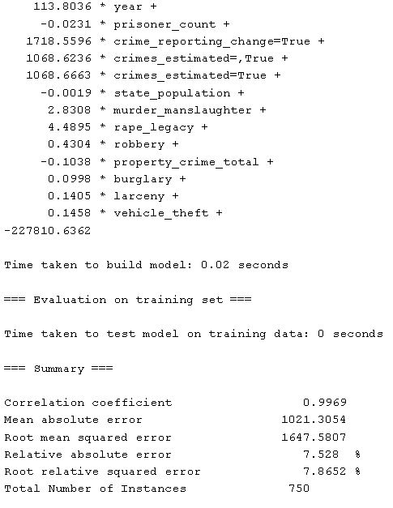

Murder manslaughter

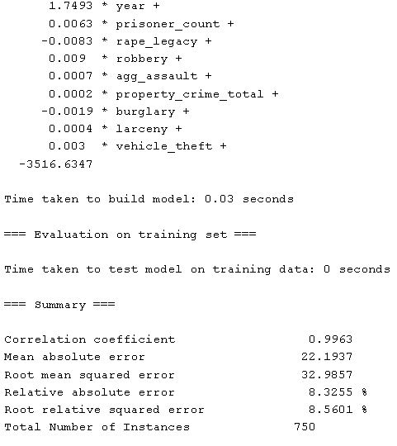

Burglary

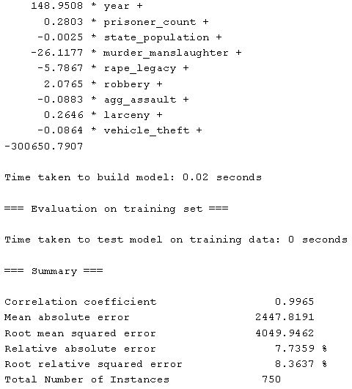

Larceny

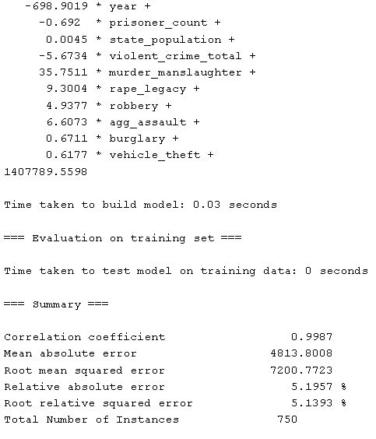

Rape legacy

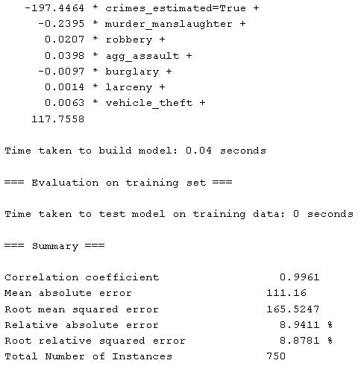

Robbery

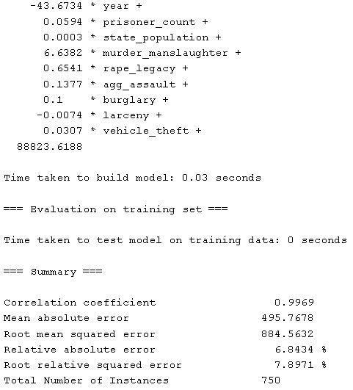

Vehicle theft

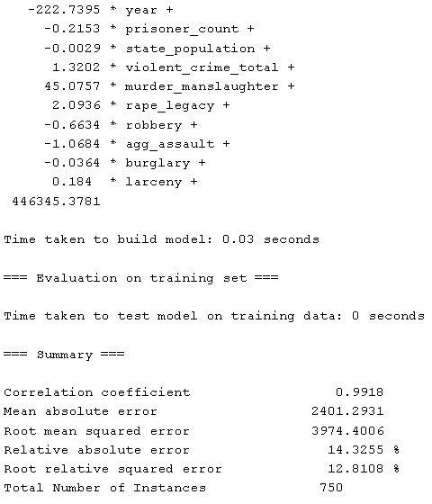

State population

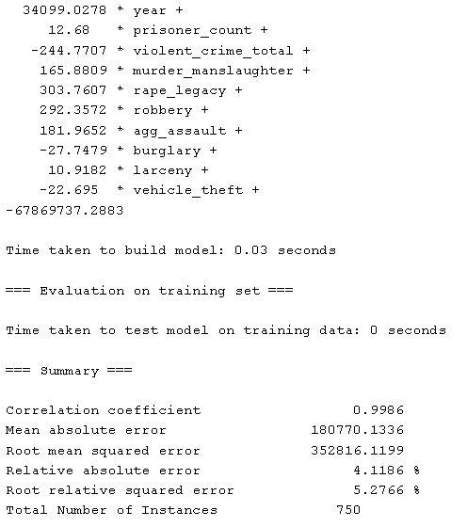

**Obtaining the Results and Interpretation**

Murder Manslaughter- Larceny-Vehicle Theft

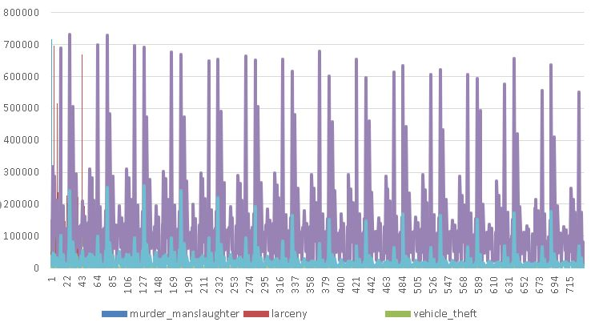

Population-Crime

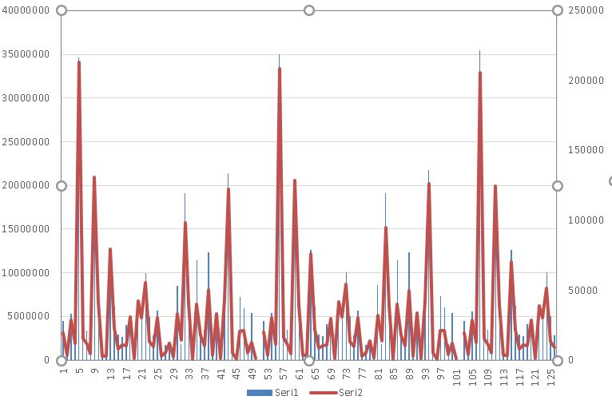

In general, it has been observed that crimes that can be considered serious do not affect other crimes. It has been determined that regions with high population density have an effect on all crimes.

It has been determined that while burglary(house robbery) reduces the murder manslaughter crime of the criminal, larceny and vehicle theft crime increase the murder masnlaughter crime.